CSC 330 - Artificial Intelligence

**Homework Assignment #2 – Informed Searching**

## Due on Friday, February 14, at the beginning of class

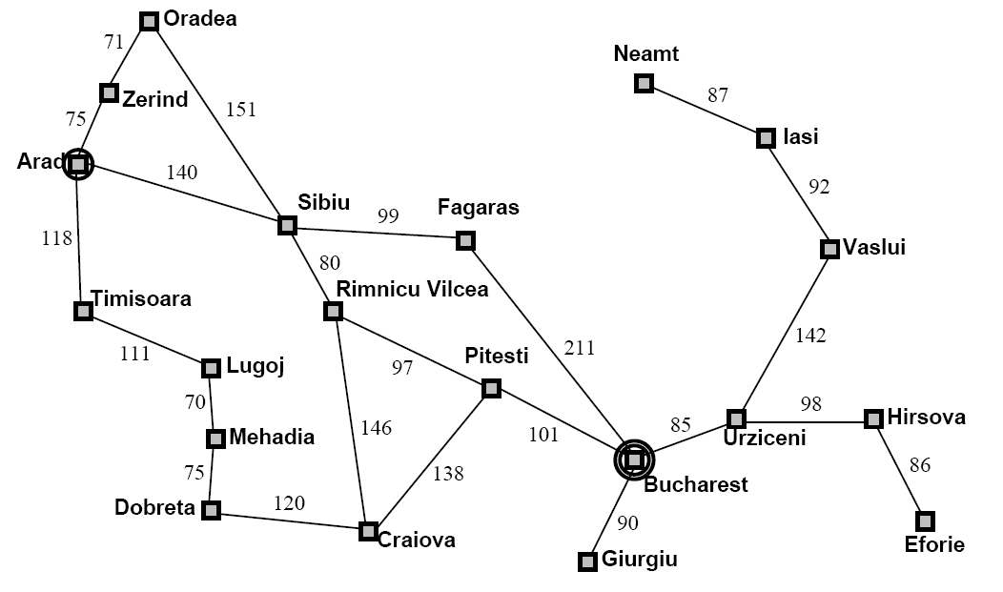

|  |  |  |  |  |  |  |  |
| --- | --- | --- | --- | --- | --- | --- | --- |
| **Straight Line Distances to Bucharest** | | | | | | | |
| Arad | 366 | Fagaras | 176 | Mehadia | 241 | Sibiu | 253 |
| Bucharest | 0 | Giurgiu | 77 | Neamt | 234 | Timisoara | 329 |
| Craiova | 160 | Hirsova | 151 | Oradea | 380 | Urziceni | 80 |
| Dobreta | 242 | Iasi | 226 | Pitesti | 100 | Vaslui | 199 |
| Eforie | 161 | Lugoj | 244 | Rimnicu Vilcea | 193 | Zerind | 374 |

1. Using the graph above, and using the straight-line distance to Bucharest of the city as the heuristic, show the results of running a ***best-first****­* search from Zerind to Bucharest. Label the nodes with the order in which they were expanded, and clearly mark the final path discovered.
2. We mentioned it in class, but did not do an example; another graph search algorithm is called ***uniform-cost*** search. This algorithm selects nodes from OPEN by their *g( )* value – it chooses the node with the smallest *g( )* value that is available. Show the results of running a uniform-cost search from Sibiu to Bucharest, using the above graph. Note the heuristic isn’t necessary for this problem.
3. Show the results of running an **A\*** search from Lugoj to Bucharest, using the above graph and the straight-line distance as the heuristic. Label the nodes with the order in which they were expanded, and clearly mark the final path discovered.